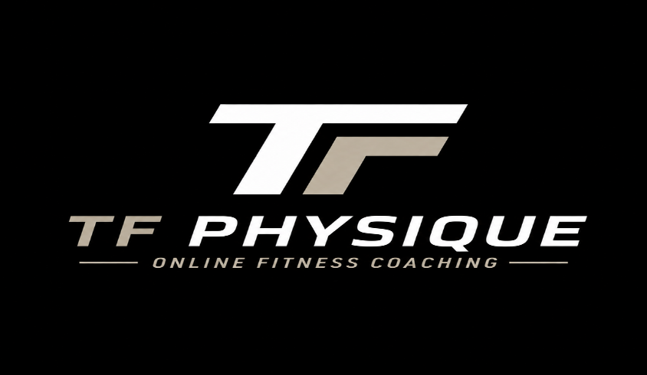

Basic Package

The Basic Package provides you with an in-depth training guide as well as nutritional information that will help you in your fitness journey. I have developed my guide through research and trial-and-error. This training provides full-body workouts consisting of primarily weight-resistance exercises. Although every muscle group is trained in this program, The Primary Focus of this training is Building Six-Pack Abs!
If you are like me, you probably have wanted to have a six-pack since you can remember. For the longest time, I would start working out and then give up, thinking that I did not have the right genetics, or I would think that in order to have a six pack, I would have to take steroids (WRONG) I have achieved a six pack through intense consistent ab training IN ADDITION to tracking calories / protein / carbs (macros).
When you sign up for this package, I will give you a phone call to go over your current level of fitness, as well as your goals and timelines. I will provide you with detailed information and a package that will (1.) Provide Exercises that Build the Abdominals and (2.) Provide you with the nutritional guidance that will help you to Lose Body Fat while Retaining your Muscle Mass.

Let’s Get to Work

