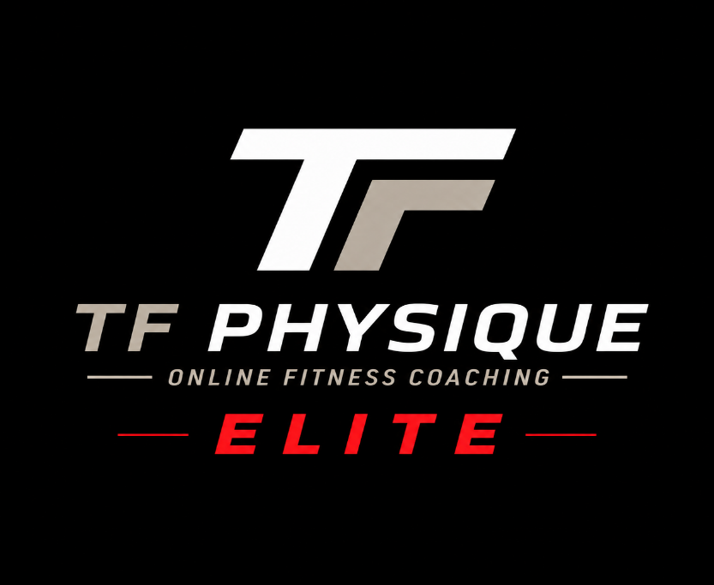

The Elite Package offers more than the basic package. It offers access to my direct line where you can text me any comments / questions throughout the day and get a timely response. It is also a little more intense than the Basic Package and requires more commitment and effort. By following this program, I can guarantee that your Abs will Pop and your body fat will be drastically lower than it ever has been.
The diet that we will come up with together will be based on foods that you like to eat and is not super restrictive / like many “only whole foods” diets that are out there. I have found that you can Build Muscle and Lose Body Fat while eating whole and processed foods. As long as you are not exceeding your caloric intake, and as long as you are hitting your protein and carb goals, you can eat a Wide range of foods (processed or not): I eat Protein bars, Ninja Creamis, Rice Krispy Treats, Preotein chips, etc…
Getting a Six Pack does not have to leave you Miserable and Hungry all of the time. The food that you will be eating with this program will be satiating and provide you with all of the macros that you need to grow those abs and lose that body fat! Under my plan you will not be eating a super low amount of calories (1800 and below is not enough to Build Your Muscles!) Eating at a low intake like that will cause you to lose weight, but you will be Losing Muscle Mass! Along with body fat. Trust me, you want to keep those Gains and only lose body fat.

LET’S GET TO IT

